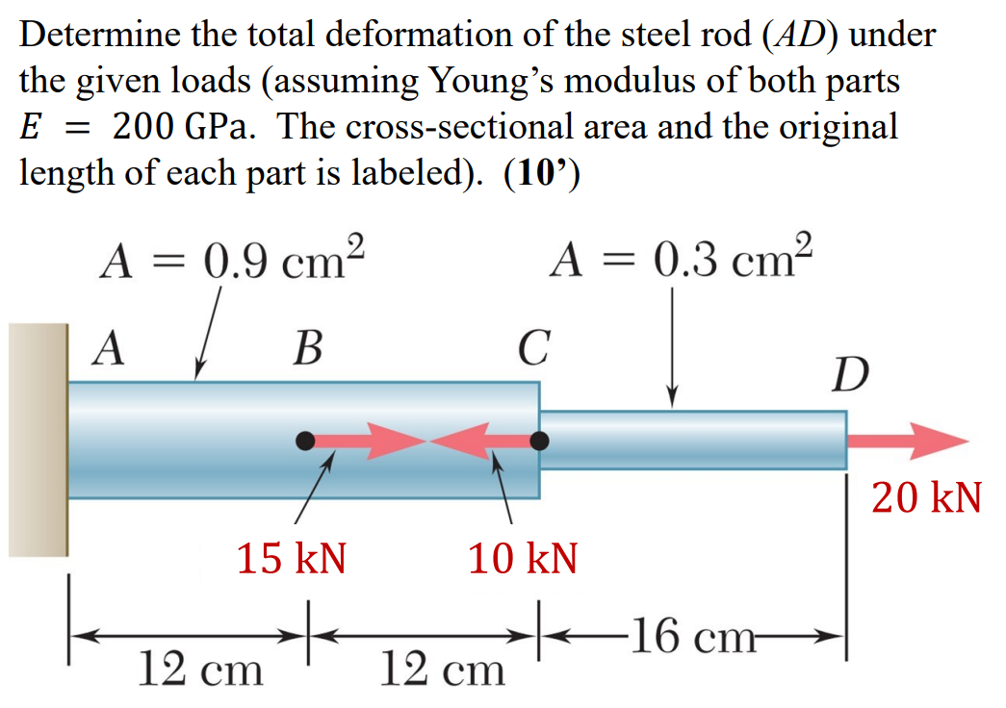
NAB=25kN; NBC=10kN; NCD=20kN
+ sign means Tension.
$$δ=∑\frac{NL}{AE}=→\frac{20*{10}^{3}*0.16}{0.00003*200*{10}^{9}}+\frac{10*{10}^{3}*0.12}{0.00009*200*{10}^{9}}+\frac{25*{10}^{3}*0.12}{0.00009*200*{10}^{9}}=0.000766m→0.766mm$$

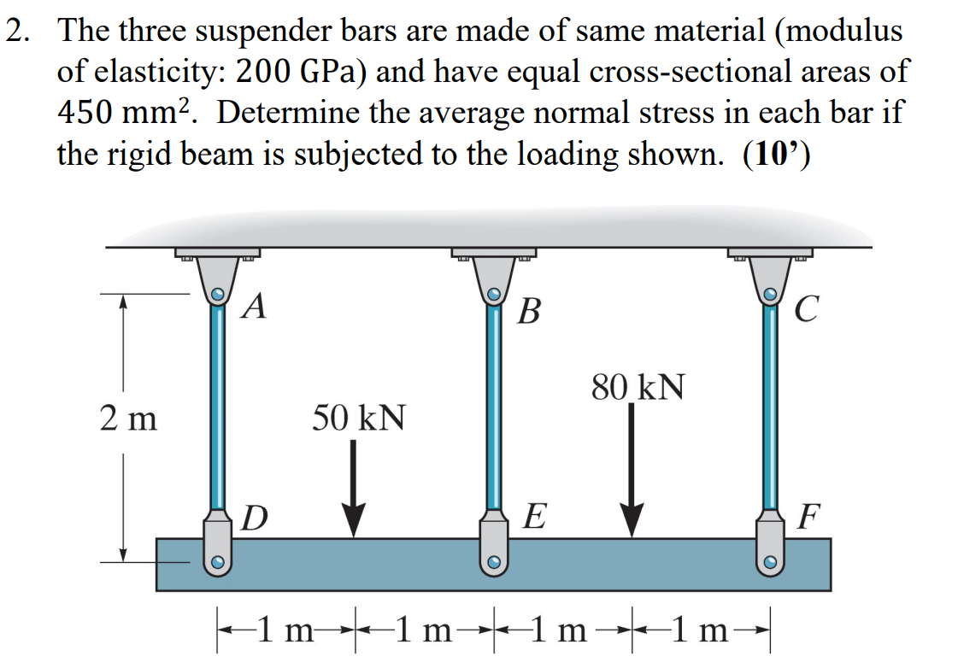
$$Fd+Fe+Ff=80kN+50kN$$
$$↻∑Mc=0; Fd\left(2m\right)-50kN\left(1m\right)+80kN\left(1m\right)-Ff\left(2m\right)=0$$
$δE=\frac{δD+δF}{2}→$Take the average of the delta of the 2 ends and that will be the delta of the center point. $δ=∑\frac{NL}{AE}$
$$\frac{Fe*2m}{0.00045m^{2}*200*{10}^{9}Pa}=\frac{\frac{Fd*2m}{0.00045m^{2}*200*{10}^{9}Pa}+\frac{Ff*2m}{0.00045m^{2}*200*{10}^{9}Pa}}{2}→$$
$$Fe=0.5Fd+0.5Ff$$
Combine all 3 equations
$$0.5Fd+0.5Ff-Fe=0$$
$$2Fd-2Ff+0Fe=-30kN$$
$$Fd+Ff+Fe=130kN$$
$$rref\left[\begin{matrix}0.5 & 0.5 & -1 & 0 \\ 2 & -2 & 0 & -30 \\ 1 & 1 & 1 & 130\end{matrix}\right]=\left\{\begin{matrix}35.833 \\ 50.833 \\ 43.333\end{matrix}\right\}$$
Accidentally put “Fe” in the last term of the matrix instead of the middle, just messes up the order below.
$$σAD=\frac{35.833kN}{0.00045m^{2}}=79.63MPa$$
$$σCF=\frac{50.833kN}{0.00045m^{2}}=112.96MPa$$
$$σBE=\frac{43.333kN}{0.00045m^{2}}=96.3MPa$$
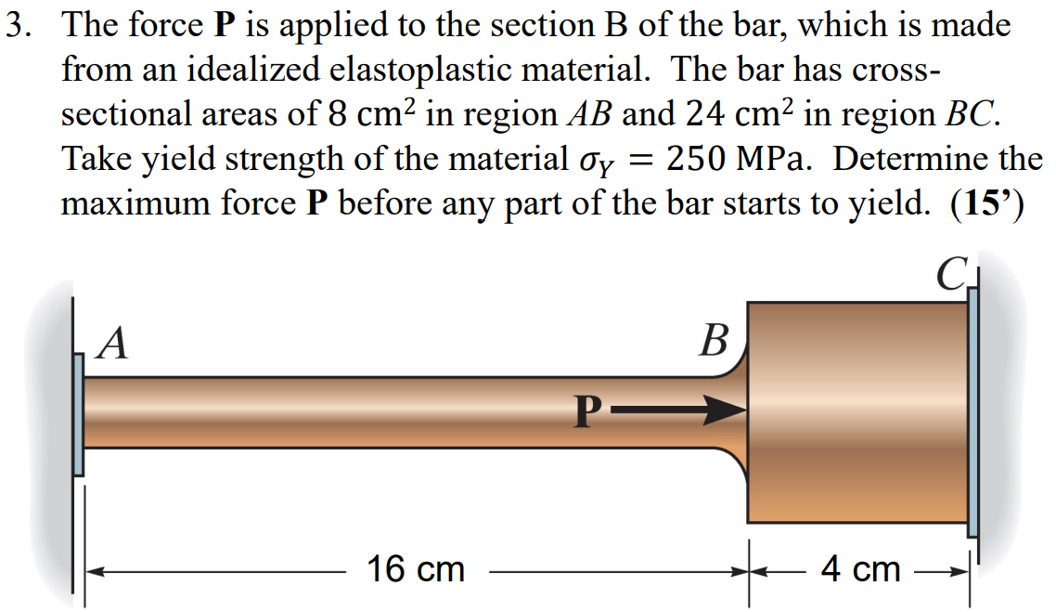
$$F1+F2=P;where F1 is force at Point A, and F2 is force at Point B.$$
$$∑δ=0; \frac{F1*0.16}{0.0008}=\frac{F2*0.04}{0.0024};E canceled out, becuase it is the same$$
$$σy=250*{10}^{6}=\frac{NAB}{8cm^{2}}=\frac{NBC}{24cm^{2}}$$
$$NAB=250*0.0008*{10}^{6}=200kN$$
$$NBC=250*0.0024*{10}^{6}=600kN$$
$$EQUATIONS$$
$$\frac{F1*0.16}{0.0008}=\frac{F2*0.04}{0.0024}$$
$$F1+F2=P$$
$$F1 Max=200kN$$
$$\frac{200,000*0.16}{0.0008}=\frac{F2*0.04}{0.0024}→F2=2.4MN$$
$$P=200kN+2.4MN=2.6MN$$
$$\frac{F1*0.16}{0.0008}=\frac{600,000*0.04}{0.0024}→F1=50kN$$
$$P=600kN+50kN=650kN$$
$$So PMax is going to be 650kN, becuase the yield strength of BC is only 600kN, which is less than 2.4MN$$

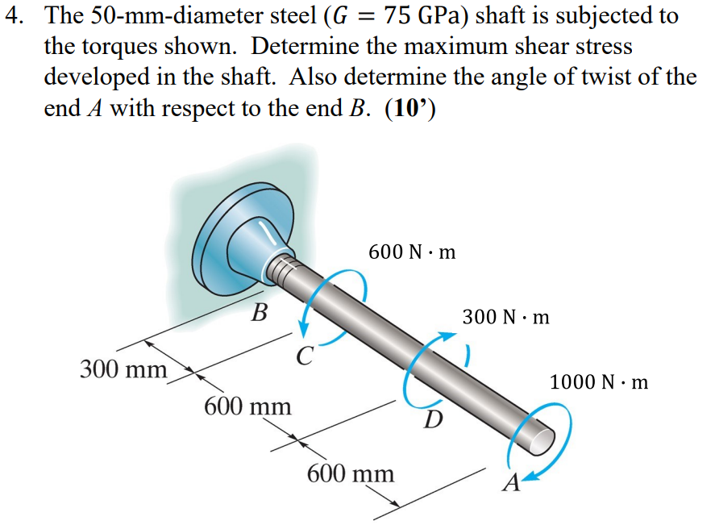
$$Inertia or J=\frac{π}{2}{\left(r\right)}^{4} or if hollow:J=\frac{π}{2}({R outer}^{4}-{R inner}^{4})$$
$$Shear stress or τ=\frac{T*r}{J}; Angle= ϕ=\frac{TL}{JG}$$
$$J=\frac{π}{2}*{0.025}^{4}$$
$$τ_{BC}=\frac{(700)N∙m*0.025m}{\frac{π}{2}*{\left(0.025m\right)}^{4}}=\frac{89.6}{π} MPa$$
$$τ_{CD}=\frac{(1300)N∙m*0.025m}{\frac{π}{2}*{\left(0.025m\right)}^{4}}=\frac{166.4}{π} MPa≅52.97MPa-Largest Shear Force$$
$$τ_{DA}=\frac{(1000)N∙m*0.025m}{\frac{π}{2}*{\left(0.025m\right)}^{4}}=\frac{128}{π} MPa$$
$$Tda=+1000N*m; Tcd=+1300N*m; Tbc=+700N*m$$
$$ϕ=\frac{0.6*1000+0.6*1300+0.3*700}{\frac{π}{2}*{0.025}^{4}*75*{10}^{9}}=0.0345506282859 rad$$

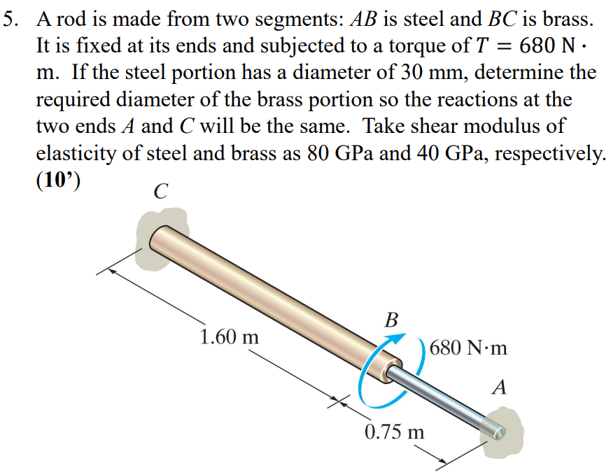
$$Inertia or J=\frac{π}{2}{\left(r\right)}^{4} or if hollow:J=\frac{π}{2}({R outer}^{4}-{R inner}^{4})$$
$$Shear stress or τ=\frac{T*r}{J}; Angle= ϕ=\frac{TL}{JG}$$
$$∑M=0;Tc+Ta=680N*m$$
$$ϕCB-ϕBA=0$$
$$\frac{Tc*1.6}{\frac{π}{2}*r^{4}*40*{10}^{9}}-\frac{Ta*0.75}{\frac{π}{2}*{0.015}^{4}*80*{10}^{9}}=0$$
$$What is wanted: Tc=Ta$$
$$\frac{1.6}{r^{4}*40*{10}^{9}}=\frac{0.75}{{0.015}^{4}*80*{10}^{9}}$$
$$r=\sqrt[4]{\frac{3.2{\left(0.015\right)}^{4}}{0.75}}→D=0.04311→43.11mm$$
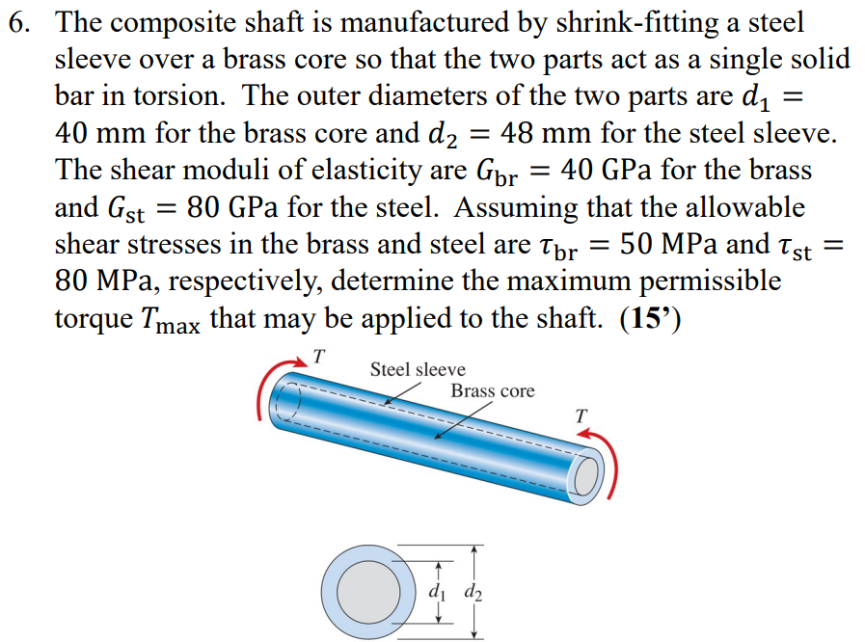
BUILDING MAIN EQUATIONS:
$$Inertia or J=\frac{π}{2}{\left(r\right)}^{4} or if hollow:J=\frac{π}{2}({R outer}^{4}-{R inner}^{4})$$
$$Shear stress or τ=\frac{T*r}{J}; Angle= ϕ=\frac{TL}{JG}$$
$$ϕst=ϕbr$$
$$T=Ts+Tb$$
$$Jbr=\frac{π}{2}*{0.02}^{4}$$
$$Jst=\frac{π}{2}*({0.024}^{4}-{0.02}^{4})$$
$$τbr=\frac{Tbr*0.02}{\frac{π}{2}*{0.02}^{4}}$$
$$τst=\frac{Tst*0.024}{\frac{π}{2}*({0.024}^{4}-{0.02}^{4})}$$
SOLVING SAID EQUATIONS
$$\frac{Tbr*L}{\frac{π}{2}*{0.02}^{4}*40*{10}^{9}}=\frac{Tst*L}{\frac{π}{2}*\left({0.024}^{4}-{0.02}^{4}\right)*80*{10}^{9}}→Tst=\frac{1342*Tbr}{625}$$
$$\frac{1342*Tbr}{625}+Tbr=T→Tbr=\frac{625}{1967}T$$
$$\frac{625}{1342}*Tst+Tst=Tst→\frac{1342}{1967}T$$
MAX TORQUE FOR EACH MATERIAL
$$T=\frac{τ*J}{r}$$
$$Tst MAX=\frac{80*{10}^{6}*\frac{π}{2}*\left({0.024}^{4}-{0.02}^{4}\right)}{0.024}=\frac{21472}{75}*π$$
$$Tbr MAX=\frac{50*{10}^{6}*\frac{π}{2}*{0.02}^{4}}{0.02}=200*π$$
$$T based on Steel Tmax→\frac{21472}{75}*π=\frac{1342}{1967}T→T=\frac{31472}{75}π≅1318.3N∙m$$
$$T based on Brass Tmax→200π=\frac{625}{1967}T→\frac{15736}{25}π≅1977.4N∙m$$
$$Steel Tmax<Brass, thus 1318.3 N∙m is the Maximum torque.$$

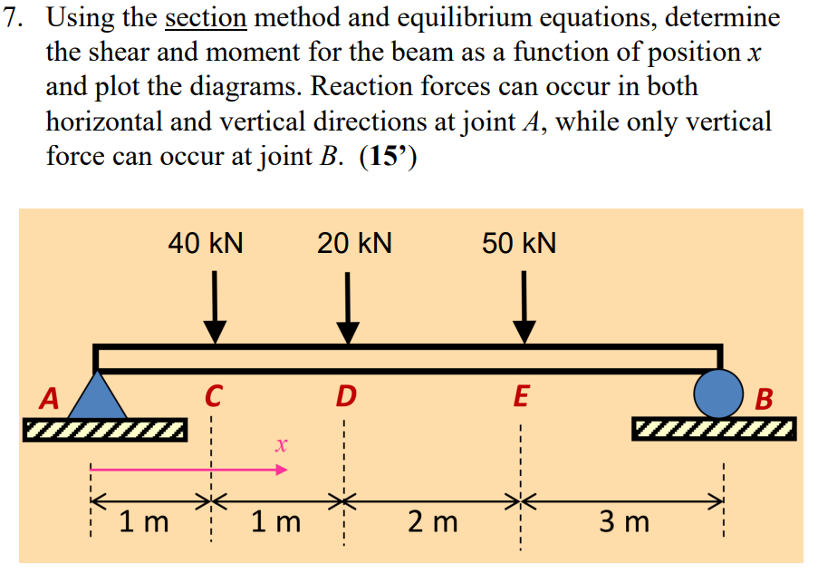
FAY+Fb=20+40+50kN=110kN
∑M=0=40000*1+10000*2+50000*4-Fb*7→Fb= 40000
FAY=70000

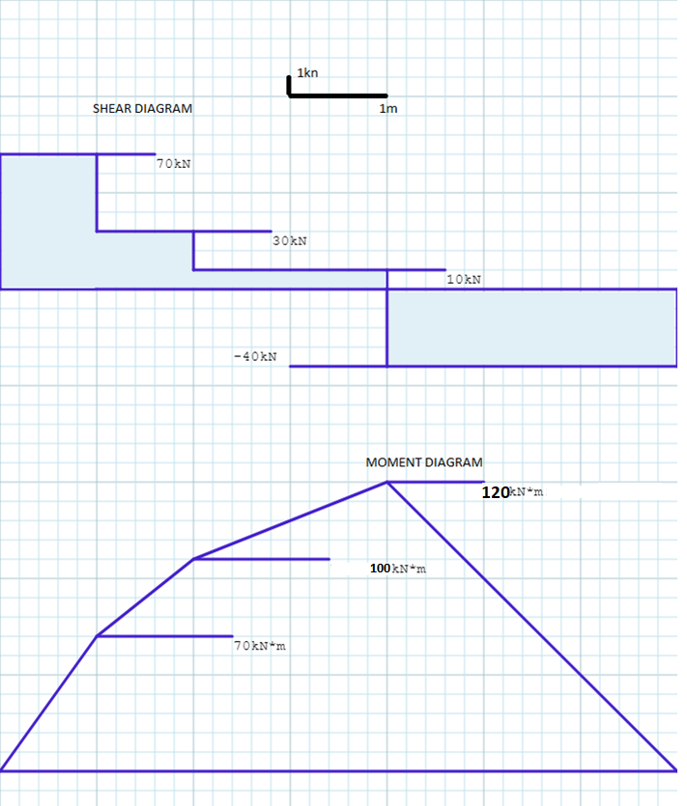

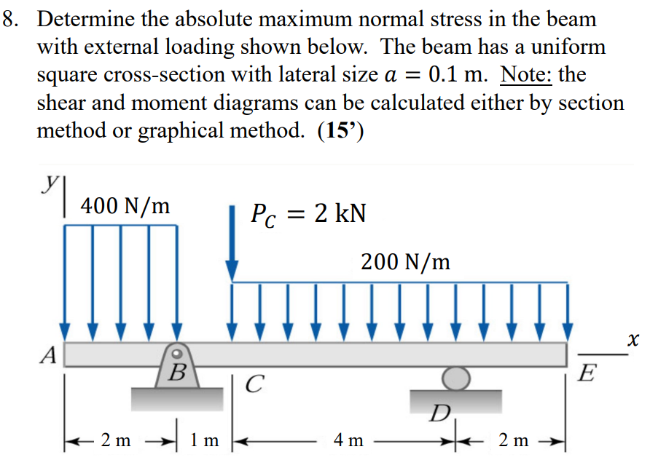
$$Fa+Fd=400*2+2000+200*6$$
$$∑MB=0; Fd*4+800*1-2000*1-1200*3=0$$
Fd=1200→ Fa=2800
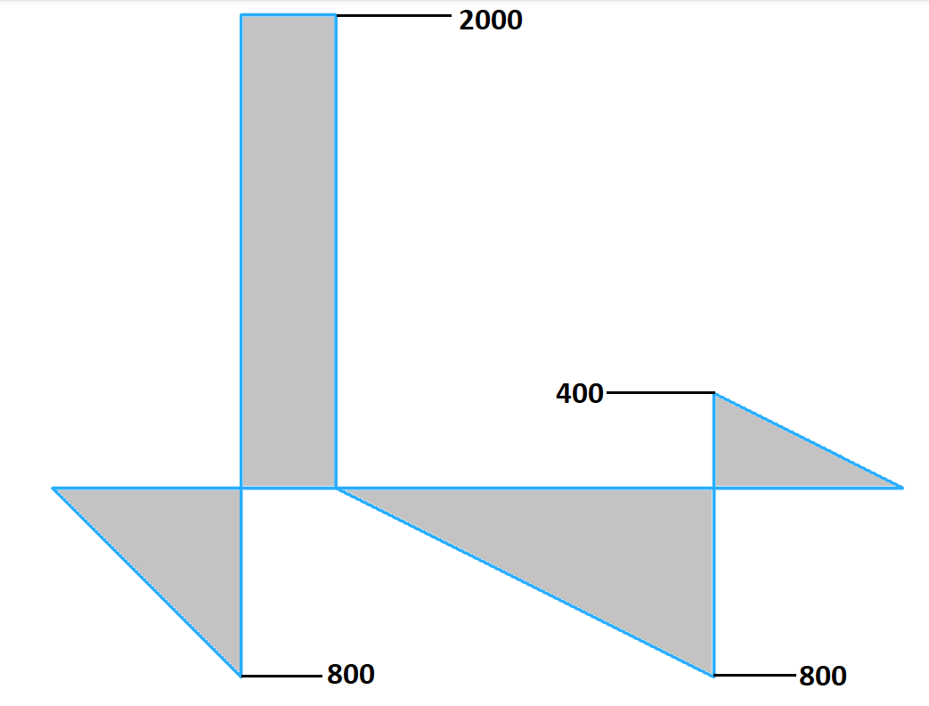
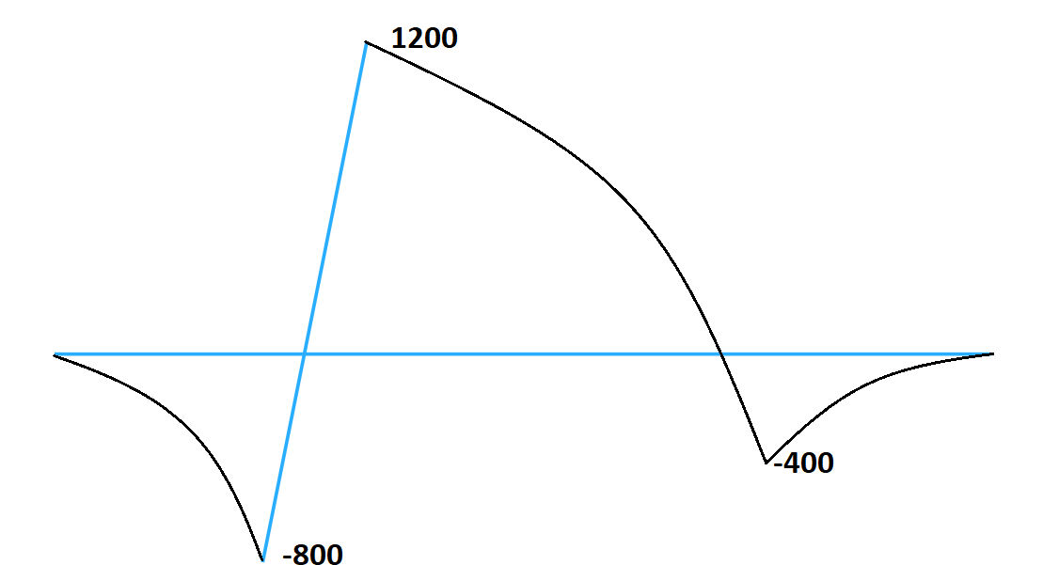
Look in the back of the book for the I equation
$$I=\frac{1}{12}*b*h^{3}$$
$$I=\frac{1}{12}*0.1*{0.1}^{3}$$
$$σ=\frac{Mc}{I}→\frac{1200*0.05}{\frac{1}{12}*0.1*{0.1}^{3}}=7.2 MPa$$

